Description
Vessels need a 4G modem to connect to the internet. This modem need to be configured correctly for the vessel in order for it to work properly.

Prerequisites

- A Digi TransPort WR44
- SIM card with 3G enabled
- PIN code (if applicable)
- APN (Access Point Name)

Procedure

To configure the Digi Connect you have to connect it directly to a desktop or a laptop with a network cable.
Once the Digi is connected to the PC you have to set a fixed IP address to be able to communicate with the Digi.

IP address: 192.168.1.20
Subnetmask: 255.255.255.0

Start Wizard

Start internet explorer and surf to http://192.168.1.1/

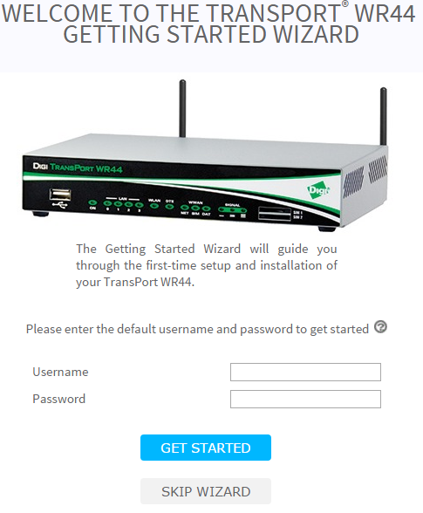

Log in with following credentials:
- Username: username
- Password: password

Configure Login credentials:

Username: root
Password: globalit
Access Level: Admin

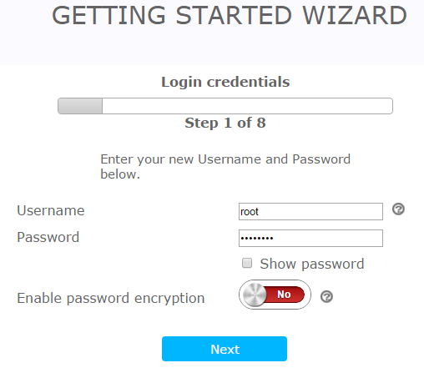

Cellular connectivity

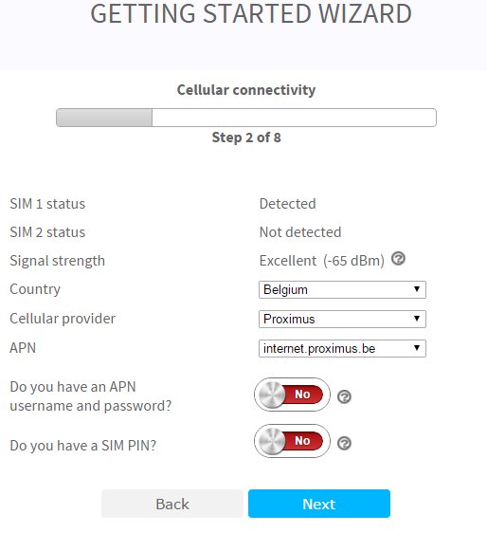
- Country:
- Cellular provider
- APN

Time configuration

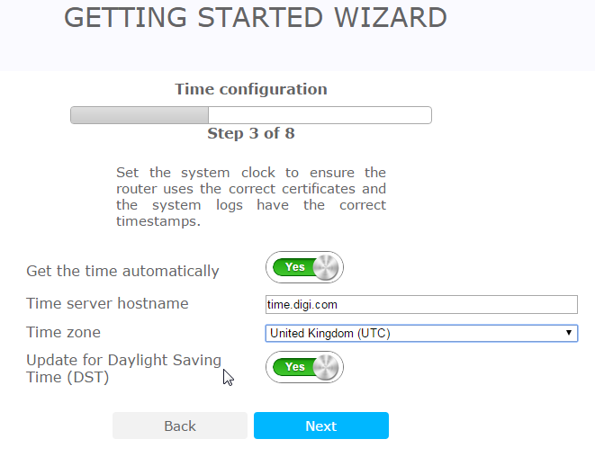

Time server: 172.16.3.22 (Timeserver new standard)
Time zone: United Kingdom (UTC)

Remote Manager

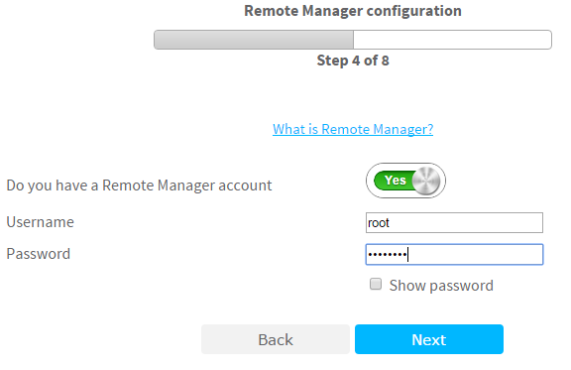

Username: root
Password: globalit

Interface Security

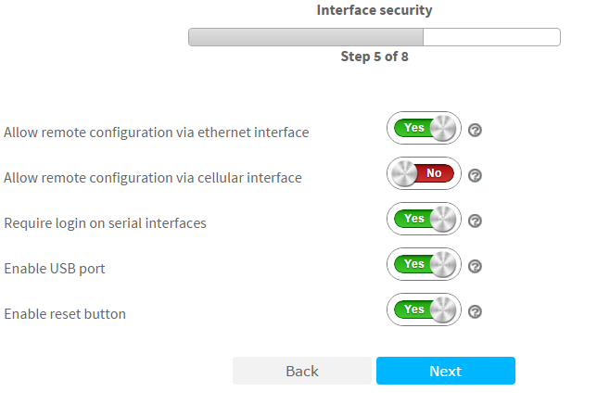

Services security

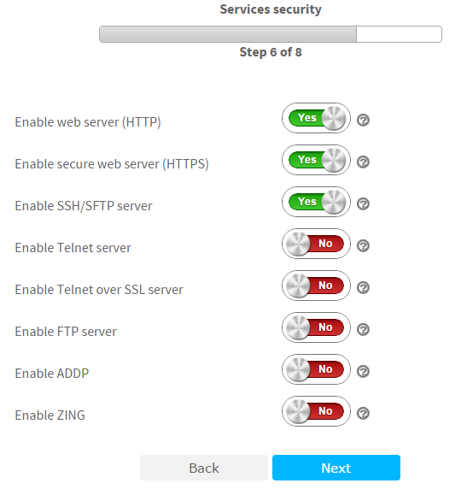

Wizard summary

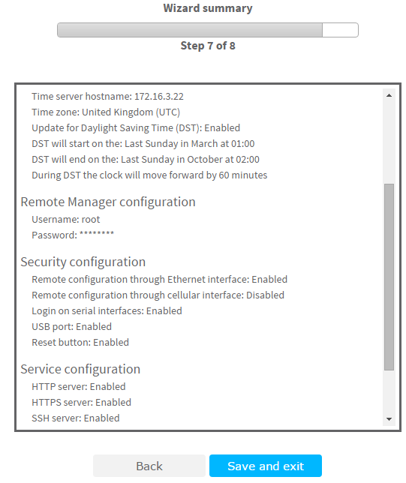

Configuration and management

Login With Root user

Users

Create User 2 with the following credentials
- Username: threeg
- Password: JDN4GV3ssels
- Access level: HIGH

Hostname

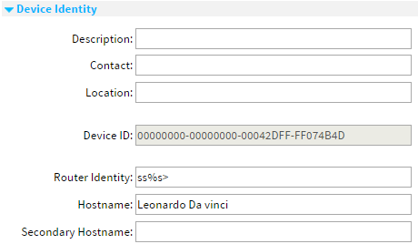

ETH 0

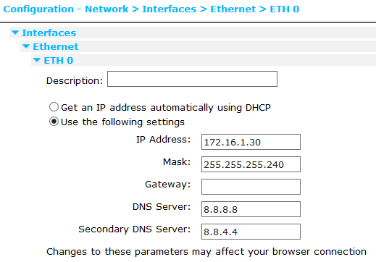

Reconfigure your local IP-address an reconnect on 172.16.1.30.

DHCP

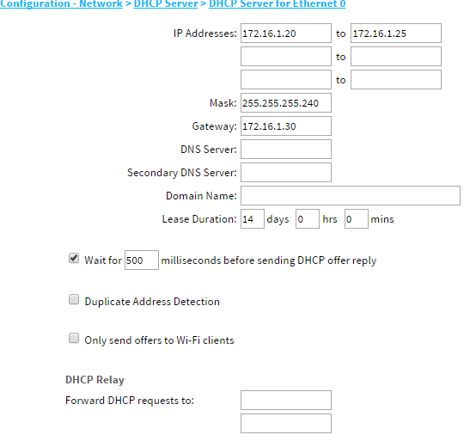

Mobile

Make sure that the SIM card is in Slot 1
Set APN settings
Enter SIM PIN (optional)

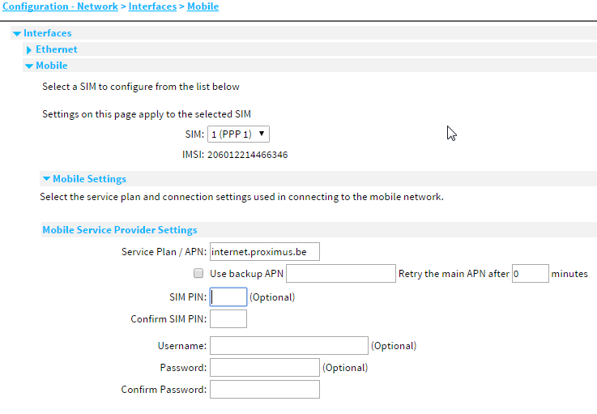

Save Configuration
